DragonEvents

By

Harley Sacramento, Haley Lee, Saffat Hasan, Rahul Gadoba

Introduction

DragonEvents is a project to change the way that Drexel students find events in University City. The idea that started DragonEvents was to improve on the Drexel events website. The main task was to improve on the user experience that Drexel events offers. The events that are going to be shown on DragonEvents will be from local businesses and other school affiliated groups. Users are able to submit events on DragonEvents to share with the community.

User’s Manual

**How to login/register:**



Click on the login button on main page or click login button on navigation bar up top.

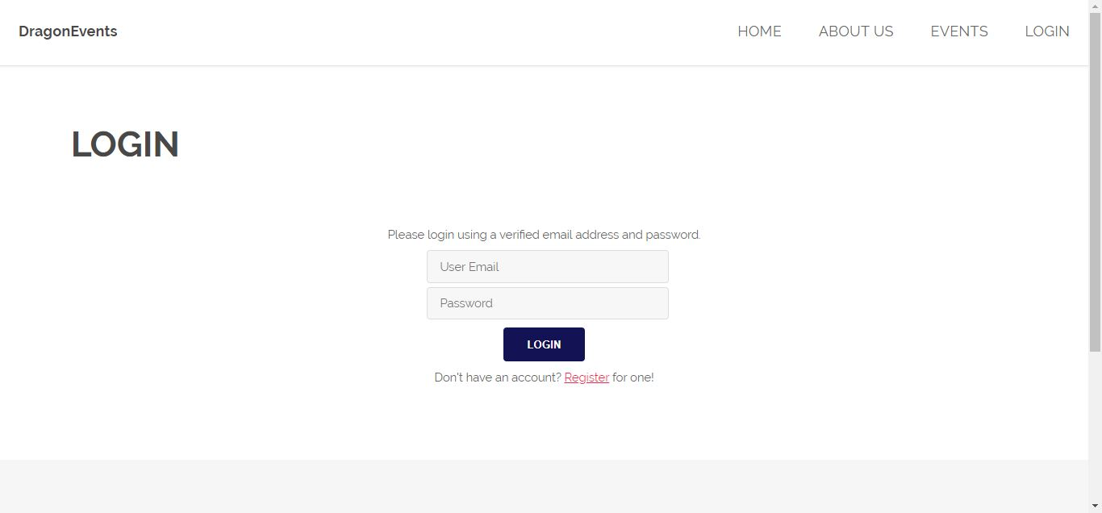

Login with your drexel email and your password. If you aren’t registered, click on register button below the login button.

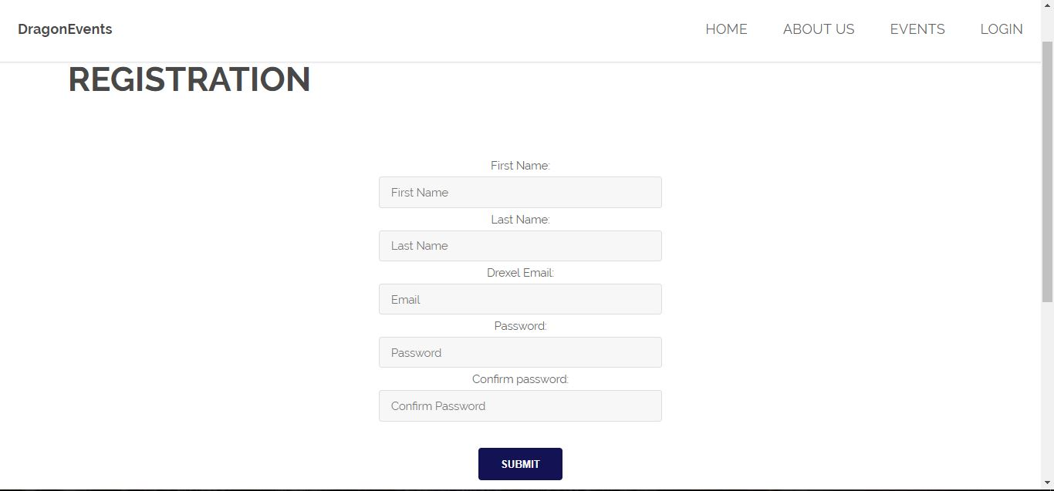

Fill in the registration form and click on the submit button. Once you submit the form, you should get a confirmation email to your registered drexel email.

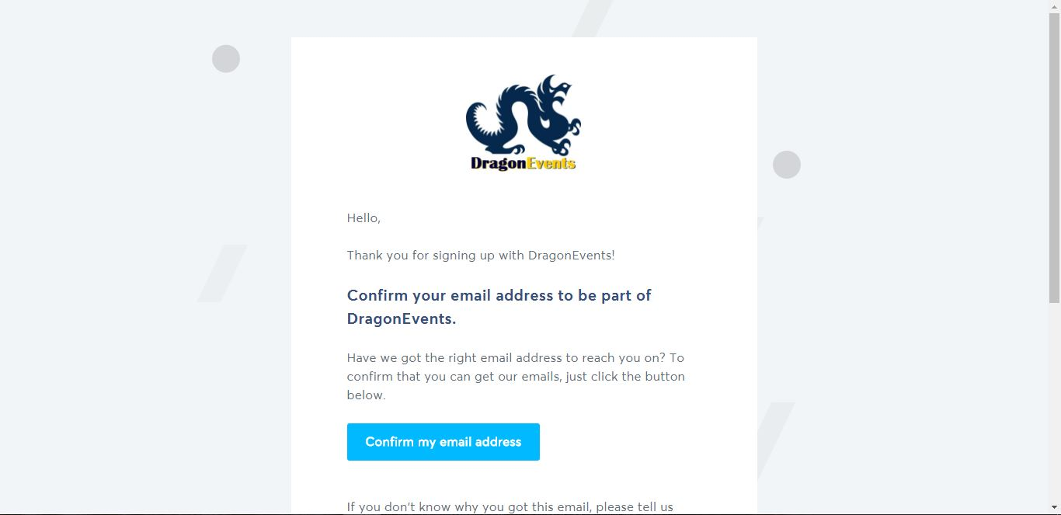

Once you receive the confirmation email, click on the button ‘Confirm my email address’ to complete your registration with DragonEvents.



Then go back to the DragonEvents website and login with your registered drexel email and password.



Once you are logged in, the main page should print out your name and you will be able to view events.

**How to view/submit events:**

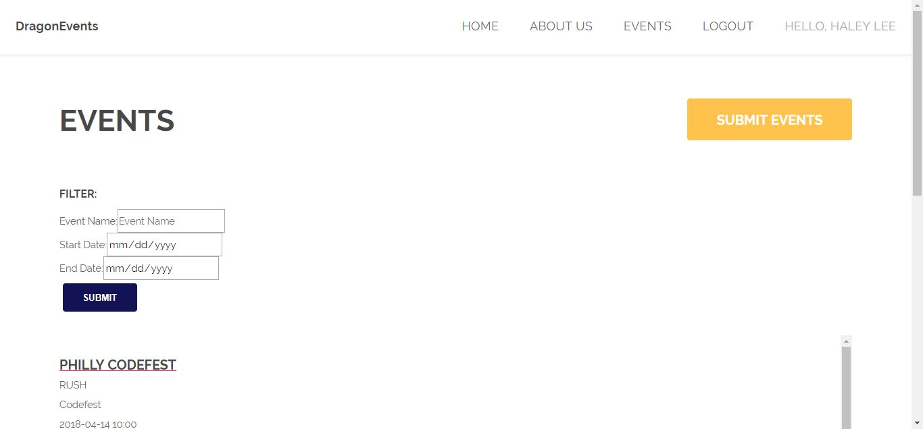

Click on the events button from navigation bar on the top of the page and you will come to the page with events listed. If you would like to submit an event on your own, click on the button that says “SUBMIT EVENTS”.

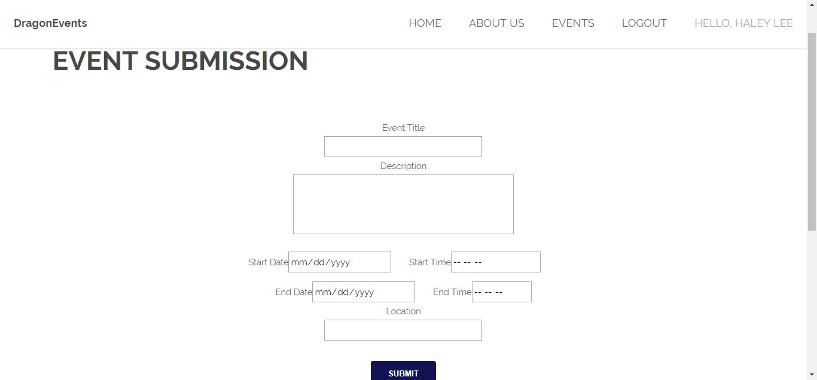

When you are at the Event Submission page, enter the correct information and make sure you fill out the required fields. Then hit submit button to submit your event.

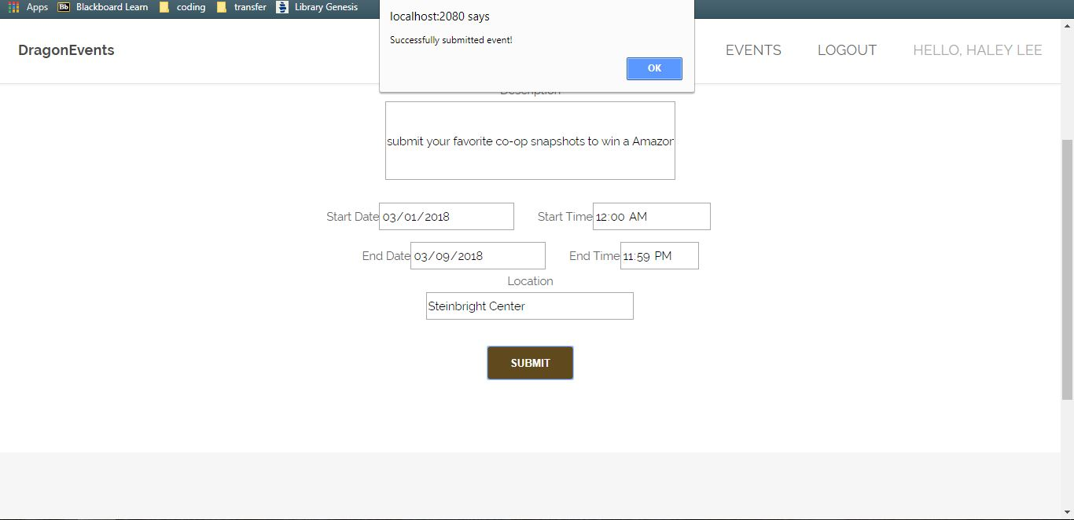

After you’ve submitted new event, there should be a prompt saying you’ve successfully submitted an event.

**How to Filter an Event:**

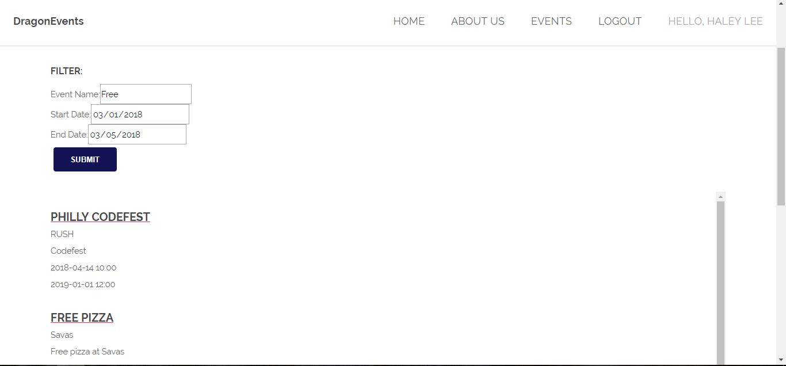

When you are at the Events page, enter the fields for your desired search. Then hit submit button to filter the events. The filtered events will be shown underneath.